­­­­­­Etude 2: Perceptron-P

//CART 360

//Felipe Dangond

**PART ONE**

I started the first part of this etude by replicating (or rather copying) the provided visual representation of the circuit diagram given onto my breadboard. After my first attempt, the circuit wasn’t fully functional and after a more in-depth examination of the diagram I realized that I couldn’t just simply translate the diagram directly as it is, onto my breadboard.

I started by building my circuit on the breadboard. I had to understand the the flow of electricity and how some different component have polarity that needs to be considered in the circuit. I did not initially understand properly the polarity on the LED’s and how the current is supposed to pass through the cathode and the anode differently. After making sure I understood the polarity and how the electricity flows through each component, I assembled a closed circuit onto my breadboard and proceeded to load the program onto the AtTiny85.

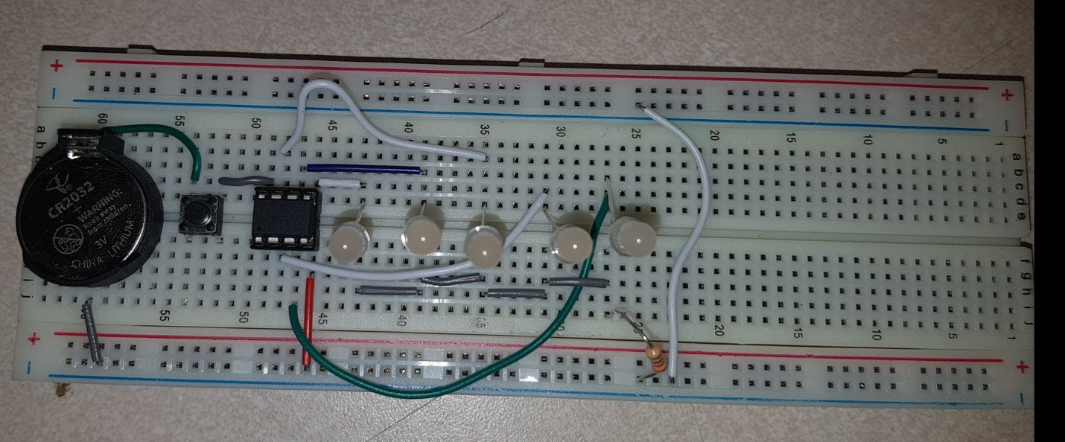

Picture of the working circuit onto the breadboard

After completing the circuit on the breadboard my initial attempt was to reproduce directly what I had done onto the perforated board and to translate the connections of each component by creating a solder connection. I did manage to reproduce the circuit but the end result wasn’t functional. I had to do a second attempt and consider how the flow electricity would pass through the solder, making sure that positive flow and ground would never touch each other (which was my problem with my initial attempt). I built my circuit dividing the negative and positive flow on two different sides (red for positive and green for ground).





**PART TWO**

The built circuit and the alternate circuit present one major difference: in the first one there’s one resistor for the five LED’s whereas in the second one, each LED has a resistor of its own. In other words, the first circuit is built in series while the second is in parallel.

In the first case, having one resistor limiting the voltage for the five diodes is not ideal. First of all, the number of led that lighten up changes depending on the letter the perceptron-p is generating which translates to a variation of light intensity depending on the situation. For example, the electrical current (or the intensity of the light) will be lesser for 5 lit LED lights than for 3. This means each LED is not constantly receiving the same amount of current all the time. The alternative circuit gives a constant current to each LED no matter the situation. Thus creating a Perceptron-p much more precise.

Another aspect that makes the second circuit more efficient than the first one is the fact that the Perceptron-P does not rely only on one resistor and can still be somewhat functional when one of the resistors is damaged. This is not the case for the other circuit which relies entirely on one resistor.